Import reports
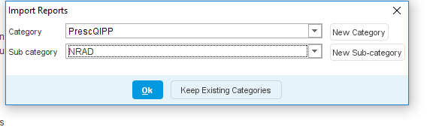
Sort searches into alphabetical order (click on Name)
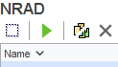
Search Title: Very High SABA use in Asthma (do report output to check quantities per script and if COPD)
This search looks for 6 or more prescriptions in the last 6 months for a SABA, for patients on the Asthma register. It is advised to run a data output to check if patients are getting more than 1 inhaler per prescription, and to also check if the patient also has COPD.
To run a data otput
Run report, and select show patients
Select all patients shown
Click on Select Output, Pre-defined output, New Pre-defined report output.
Give your output a name
Configure the output: Add demographics, read code for COPD, Select Short acting beta agonists (relievers) drug group.
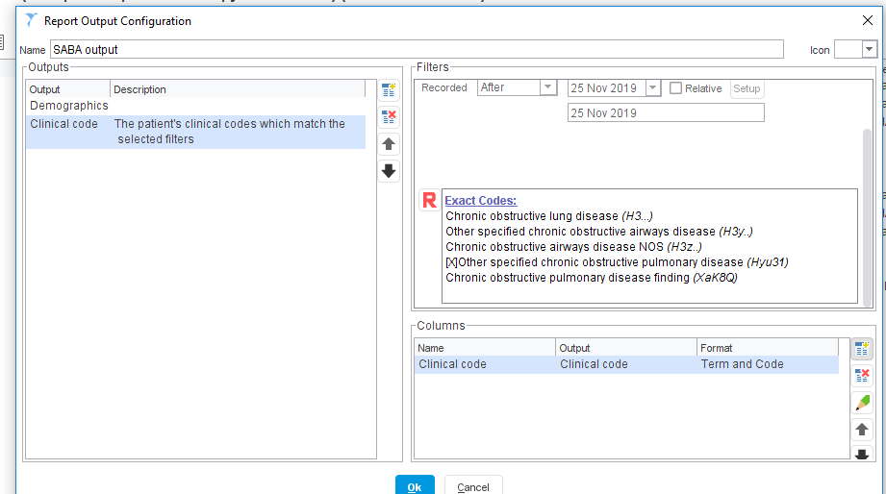
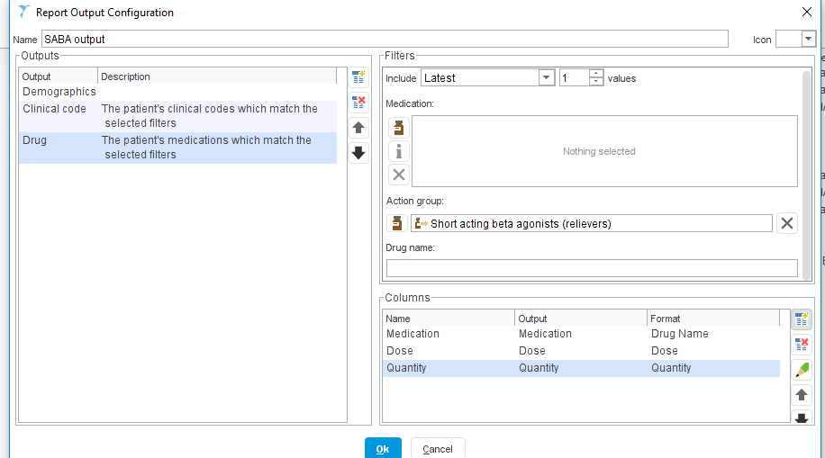

All patients in this report have had more than 6 relievers issued in the last 6 months. By breaking down by quantity any on more than 1 per prescription can be identified
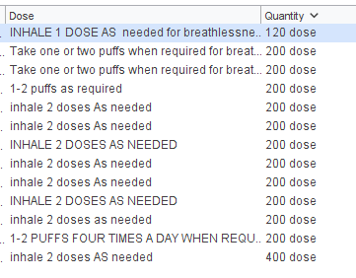
To identify the highest users, you can breakdown the report my prescription count.
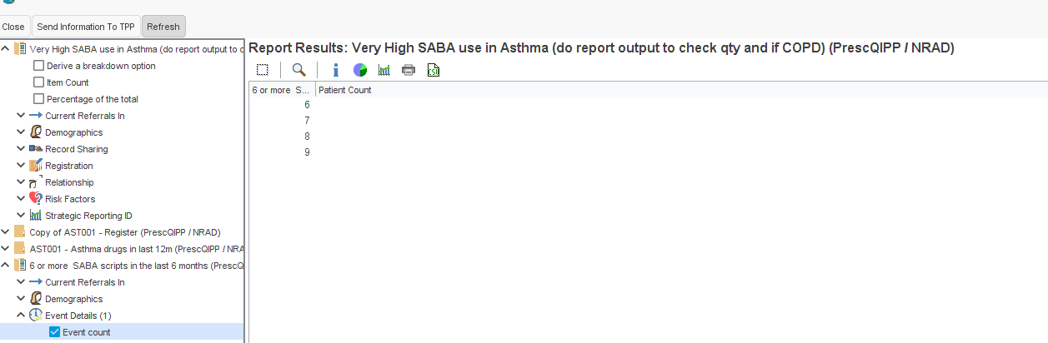

Select the list of patients with 6 prescriptions in 6 months, and then use the report output as above to show how many inhalers have been issued in 6 months, and also show if they also have COPD.
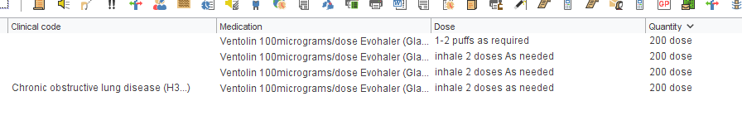
To identify all patients who have had more than 6 inhalers issued in the last 6 months, it is important to breakdown reports for those who have had 2,3,4 or 5 prescriptions issued, to make sure none are having 2 or 3 inhalers per prescription.
Run search title: Very High SABA use if getting more than 1 per script (need to run data output)
Shows patients and apply the data output as detailed previously.
You can click on quantity and sort by quantity, those having more than 1 inhaler per issue, will need looking at individually to check the number of issues in the last 6 months.
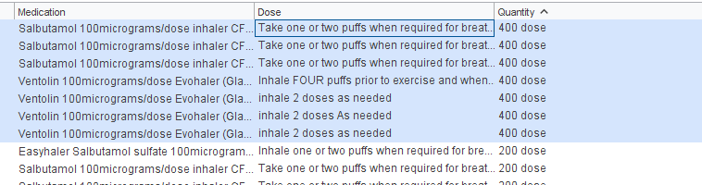

Report Title: High SABA
This search will identify all patients who have had 3 or more prescriptions in the last 12 months, who have Asthma. As above use the same report output to breakdown by quantity.
You can also breakdown the report by number of prescription, and sort into highest users first.

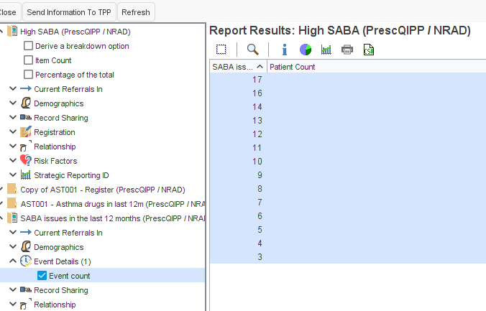

To capture those patients having 2 or 3 inhalers per prescription, run the following report and use the data output.
1 SABA script issued in the last 12 months (only those with a quantity of 3 will need to be looked at)
And
2 SABA scripts issued in the last 12 months (those with a quantity of 2 and 3 need to be looked at)

Report Title: LABA alone in asthma
This reports searches for any patient with an asthma diagnosis on a LABA with no repeat for single ICS inhalers issued in the last 3 months.

Report title: LABA and ICS in separate devices
Search looks at all patients with Asthma, on any LABA alone device plus an ICS inhaler.

Report title: Asthma self-management plan not given in last year
Search looks for all asthma patients with no record of the following codes recorded in the last 12 months.
Asthma clinical management plan (736056000)
Asthma management (406162001)
Asthma self-management plan agreed (811921000000103)
Asthma self-management plan review (810901000000102)
Change in asthma management plan (390872009)
Patient has a written asthma personal action plan (527171000000103)

Report title: Non-adherence to ICS

There are 2 searches to run

Non-adherence to ICS (28 and 50day inhalers) : This search identifies patients who have had less than 12 ICS or ICS/LABA inhalers prescriptions in the last 12 months (for inhalers which last 30 days) and those with less than 7 prescriptions for inhalers which last 50 days (eg Clenil or Soprobec)
You will need to check that the patients identified are having 1 inhaler per prescription, and that the directions reflect 30 day use.
Build a data output to check for directions and quantities.
Data output fields shown below.

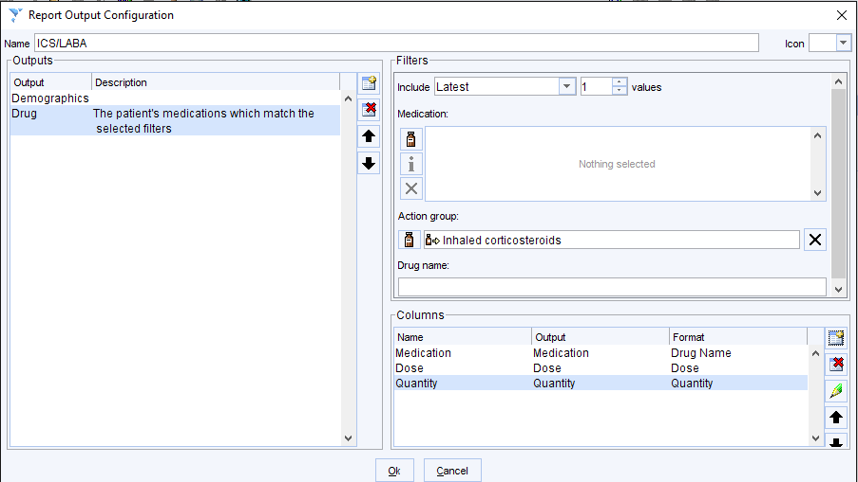

Export into excel. Ensure all directions reflect 1 inhaler per month, or 1 per 50 days for 200 dose inhalers. Remove any patients on inhalers with directions which mean that they will last longer than this eg Fostair 100/6 1 puff bd.
The remaining list, is for patients who are not ordering inhalers to show full adherence. The only exception to this, is for patients who have been recently started on treatment, or new to the surgery.

Then run
Non-adherence to ICS (56 and 100day inhalers)
Use the same data output to check directions and quantities.
You want to identify all those on 56/60 and 100days per prescription.
The list you have will be all patients who are not ordering inhalers to show full adherence.

Report title: Poor inhaler technique or no inhaler technique recorded

Search looks for all patients with Asthma or COPD, who have had poor inhaler technique recorded in the last 12months, or those with no inhaler technique recorded in the last 12 months.

Report title: No asthma review in the last 12 months
Search looks at all patients on the Asthma register who have not had an asthma review recorded in the last 12 months.

Report titles:
ED or OOH service attendance due to asthma attack
Hospital admission for asthma
2 or more ED attendances for asthma attack in the last 12 months

Run search: ED or OOH service attendance for asthma attack - check each record to see if ED,OOH or Admission
Each record will need to be viewed to check for ED, OOH, or Hospital admission.

Report title: More than 2 courses of oral steroids in the last 12 months
Search looks for patients who have had 2 or more prescriptions for oral prednisolone in the last 12 months, with Asthma. You may want to use a data output to highlight any patients who also have COPD.

Report title: Taking theophylline, B agonist tablets or LAMA with Asthma
Search looks for patients with Asthma with a repeat prescription for Aminophylline, Theophylline, B agonist tablets or Spiriva Respimat.
Patients may also have COPD, so you may want to show by running a data output.

Report title: High dose ICS in adults
Search looks at patients 17 and older, who have had ICS/LABA being issued at the frequency outlined in appendix 1. It searches on the number of issues/prescriptions in the last year.
The search assumes one inhaler per prescription.
To identify anyone on more than 1 inhaler per prescription, run ICS or ICS/LABA on repeat search, and use a data output to check for age of patients and quantities. Remember anyone having more than 1 inhaler pre prescription may not get picked up in the high dose ICS in adults search.
Use a data output to show the inhaler prescribed and dose, and to check they have asthma.

Report title: Paediatric high dose ICS in children and young people
Search looks patients 16 and younger, who have had ICS/LABA issued at the frequency in appendix 2. It searches on the number of issues/prescriptions in the last year.
The search assumes one inhaler per prescription.
To identify anyone on more than 1 inhaler per prescription, run ICS or ICS/LABA on repeat search, and use a data output to check for age of patient and quantities. Remember anyone having more than 1 inhaler pre prescription may not get picked up in the Paediatric high dose ICS search.
Use a data output to show the inhaler prescribed and dose, and to check they have asthma.

