Guidance for GPs on reviewing and stopping antipsychotics prescribed for behavioural and psychological symptoms of dementia (BPSD)
- All patients with dementia currently on antipsychotics for behavioural problems who have not had a trial discontinuation in the last 3 months should have the antipsychotic reviewed and stopped to assess the risks and benefits of continued treatment unless:
- The antipsychotic was prescribed for a pre-existing condition prior to a diagnosis of dementia, e.g. bipolar disorder or psychotic depression.
- The patient is under regular review by a specialist for behavioural problems. This does not include reviews solely planned to assess the on-going benefits of prescribing cholinesterase inhibitors (e.g. donepezil) to delay cognitive decline.
- There is a detailed care plan in place for ongoing antipsychotic use.
- There may be some patients with undiagnosed dementia prescribed antipsychotics that need reviewing. Consider running a report on patients on an antipsychotic to discover those that do not have a linked diagnosis requiring antipsychotics.
- If the patient is under regular review by secondary care for behavioural problems then responsibility for reviewing and reducing or stopping the antipsychotic lies with secondary care, otherwise this should be undertaken by the patient’s GP.
- If a decision is made to reduce or stop an antipsychotic, carers should be involved in the decision and supported through the process.
- Carers should be:
- Given information on why the treatment is being stopped, including a written leaflet or information in another suitable format.
- Asked to keep a diary of the patient’s behaviour from a week before stopping or reducing the dose to a week after the reduction or stop date to assess the impact more objectively of reducing and/or stopping the treatment
- Given a contact number in case the patient’s behaviour deteriorates significantly.
- Left with a small supply of the drug, which can be reinstated if agreed with the prescriber.

Suggested pathway for a person who has already been prescribed antipsychotic drugs (adapted)
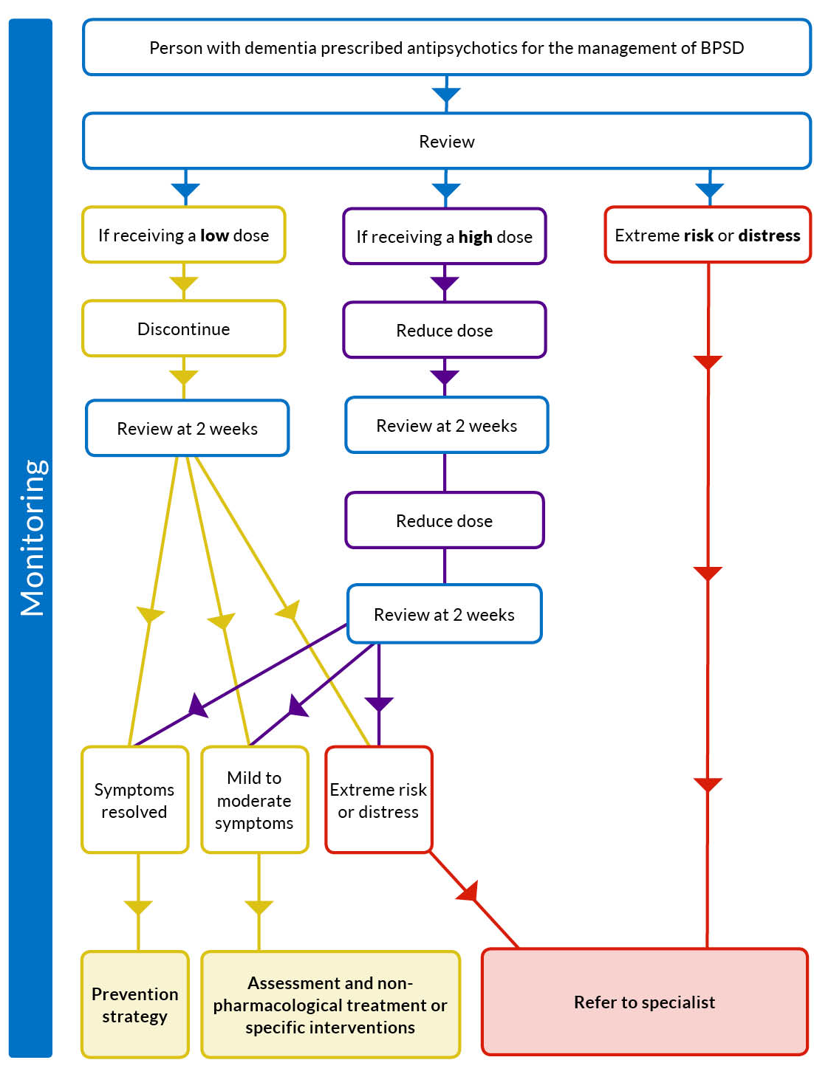

Suggested protocol for reducing and stopping antipsychotics
If the person is receiving a “low dose” proceed directly with discontinuation and monitoring.
Antipsychotic | Suggested daily low dose*
Aripiprazole | Less than 5mg
Olanzapine | Less than 2.5mg
Quetiapine | Less than 50mg
Risperidone | Less than 0.5mg
Haloperidol | Less than 0.5mg
Amisulpiride | Less than 50mg
*Suggested “low dose”, but consult the BNF www.bnf.org
- If the person is receiving a higher dose, taper the dose over one month:
- Reduce to half dose for two weeks
- GP review at two weeks
- Discontinue immediately after a further two weeks
- Review every stage of dose reduction to evaluate patient response
- If a very high dose was recommended by secondary care, get advice from them before making any changes. The following is a guide for the most commonly used medicines, but individual patient circumstances and the views of the carer may need to be taken into consideration.
Drug | Total daily dose | Step 1 | Step 2 | Step 3
Risperidone | Up to 500 micrograms | Stop
Risperidone | Up to 1mg | Halve dose | Stop
Risperidone | Over 1mg | Halve dose | Halve dose | Stop
Quetiapine | 25mg | Stop
Quetiapine | Up to 50mg | Halve dose | Stop
Quetiapine | Over 50mg | Halve dose | Halve dose | Stop
Haloperidol | Up to 500 micrograms | Stop
Haloperidol | Up to 1mg | Halve dose | Stop
Haloperidol | Over 1mg | Halve dose | Halve dose | Stop
- In some cases it may be necessary to withdraw the drug more slowly, particularly if symptoms reappear.
- Implement small decreases in dose (ensure dose reduction is possible with strengths available), one step down at a time.
- Where the antipsychotic is given more than once daily, decrease only one dose to start with, choosing the dose where patient likely to be least affected.
- Allow sufficient time for the patient to adapt to the new dose (usually 1-2 weeks) before considering the next small reduction in dose.
- When the lowest dose has been achieved on a daily basis then administer on alternate days before stopping completely.

- A minimum of two weeks should be left between any dose reduction and a review to consider stopping or a further dose reduction, though longer periods can be allowed if there are clinical or carer concerns.
- If behavioural problems continue then other strategies should be considered instead of, or alongside, a short six-week course of antipsychotics such as regular pain relief or behavioural strategies, based on an individual assessment.
- If antipsychotics are reinstated this should only be done if the benefits outweigh the risks for that individual patient. Consider starting low again, even if the dose stopped was higher.
- If a decision is made to continue the antipsychotic beyond this first six weeks then all future treatment should be prescribed as courses, up to a maximum of three months, with a suggested stop date of a Monday, so benefits and risks can be reassessed at regular intervals during the working week.
- Risperidone is currently the only licensed antipsychotic in dementia, for short-term treatment (up to 6 weeks) of persistent aggression in patients with moderate to severe Alzheimer’s disease unresponsive to non-pharmacological interventions and when there is risk of harm to self or others. Alternative antipsychotic drugs include olanzapine, aripiprazole and quetiapine. The evidence relating to these drugs is more limited. Of particular note, evidence shows that quetiapine is ineffective in treating behavioural and psychological symptoms in dementia and cholinergic side-effects may be a particular concern.
- If an antipsychotic is indicated, weekly monitoring of sedation, fluid intake and early indicators of chest infection is strongly recommended.
TOP TIPS
It is recommended that when reviewing a number of patients in a care home, the stopping of treatment is staggered and those patients considered to be the most likely to not need the antipsychotic are stopped first, to give the home confidence in the process.
Bear in mind that in the elderly it is good practice to only change one medicine at a time when deciding whether to reduce or stop an antipsychotic.
Any stop date should usually be planned for a Monday so that if behavioural symptoms reappear these can be assessed during the working week.
If the antipsychotic is stopped, make sure the repeat prescribing record is updated to prevent a further supply being prescribed.
For support or advice on reducing, stopping or restarting antipsychotics the following people/teams can be contacted.
Name of individual or team | Contact details | Other relevant information i.e. working hours

