


Patient Name Doctor or Nurse practitioner recommended that you self-care

Your infection |  | Without antibiotics, most are better by | How to look after yourself and your family | When to get help
 | Middle-ear infection | 8 days | - Have plenty of rest.  - Drink enough fluids to avoid feeling thirsty.  - Ask your local pharmacist to recommend medicines to help your symptoms or pain (or both).  - Fever is a sign the body is fighting the infection and usually gets better by itself in most cases. You can use paracetamol if you or your child are uncomfortable as a result of a fever.  - Use a tissue and wash your hands well to help prevent spread of your infection to your family, friends and others you meet.  - Other things you can do suggested by GP or nurse:  .................................................................................................................. | The following are possible signs of serious illness and should be assessed urgently:  - If your skin is very cold or has a strange colour, or you develop an unusual rash.  - If you feel confused or have slurred speech or are very drowsy.  - If you have difficulty breathing. Signs that suggest breathing problems can include:  - breathing quickly  - turning blue around the lips and the skin below the mouth  - skin between or above the ribs getting sucked or pulled in with every breath.  - If you develop a severe headache and are sick.  - If you develop chest pain.  - If you have difficulty swallowing or are drooling.  - If you cough up blood.  - If you are feeling a lot worse.  If you or your child has any of these symptoms, are getting worse or are sicker than you would expect (even if your/their temperature falls), trust your instincts and seek medical advice urgently from NHS 111 or your GP. If a child under the age of 5 has any of symptoms 1-3 go to A&E immediately or call 999.  Less serious signs that can usually wait until the next available appointment:  - If you are not starting to improve a little by the time given in the ‘Most are better by’ column.  - In children with middle-ear infection: if fluid is coming out of their ears or if they have new deafness.  - Mild side effects such as diarrhoea, however seek medical attention if you are concerned.  - Other ……………………………………………………………………………………………………
 | Sore throat | 7 - 8 days
 | Sinusitis | 14 – 21 days
 | Common cold | 14 days
 | Cough or bronchitis | 21 days
 | Other infection:  ..........................................  ..................... | ....... days
- Antibiotics may be required after days only if you are not starting to feel a little better or you feel worse. Contact your GP practice

- Colds, most coughs, sinusitis, ear infections, sore throats, and other infections often get better without antibiotics, as your body can usually fight these infections on its own.
- Taking antibiotics encourages bacteria that live inside you to become resistant. That means that antibiotics may not work when you really need them.
- Antibiotics can cause side effects such as rashes, thrush, stomach pains, diarrhoea, reactions to sunlight, other symptoms, or being sick if you drink alcohol with metronidazole.
- Find out more about how you can make better use of antibiotics and help keep this vital treatment effective by visiting www.nhs.co.uk/keepantibioticsworking

Never share antibiotics and always return any unused antibiotics to a pharmacy for safe disposal. Leaflet developed in collaboration with professional medical bodies.
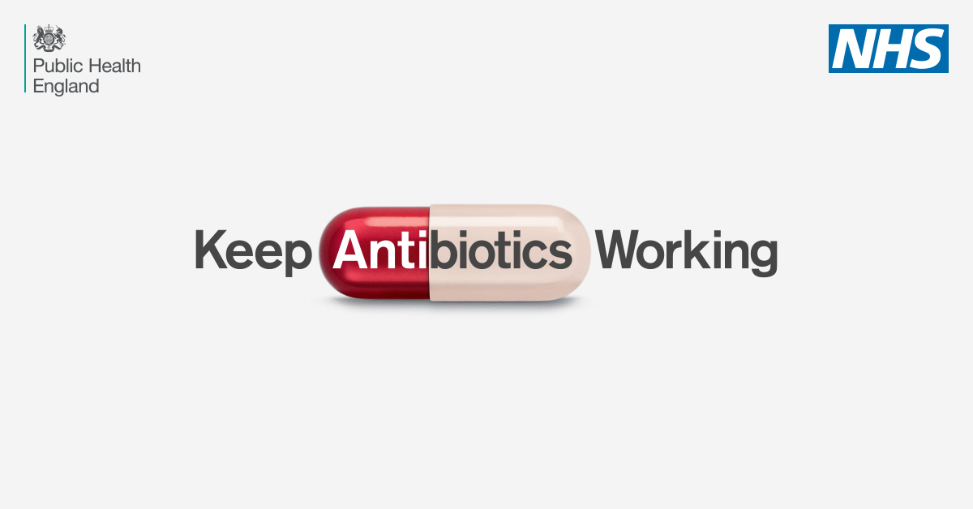












Version: OOH V8
Published: November 2017
Revision: November 2020

