Dear
I am contacting you as we have been reviewing prescriptions relating to controlled drugs including one for:
name
DOB
address
prescriber number
prescriber name
practice / hospital
date of script

A potential concern has been identified:
Drug | Dose | Quantity | repeat (R) or acute(A)
opiate dose appears to be over 120mg oral morphine( equivalent) daily (Not end of life) |  |  |  | tick
combination opiates with pregabalin / gabapentin
combination of opiates with benzodiazepines
frequency of repeats / scripts quantity
other please specify

I would be grateful if you would review this patient’s medication to ensure prescribing is in line with current guidance to promote patient safety

Many thanks for your help
name
address
email
phone number
Signed
date

CDAO copied in? | yes | Reason

- Opioids aware. https://rcoa.ac.uk/faculty-of-pain-medicine/opioids-aware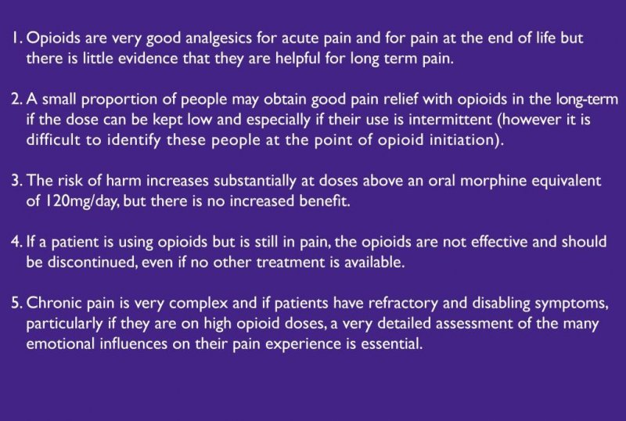
- https://www.gov.uk/government/uploads/system/uploads/attachment_data/file/385791/PHE-NHS_England_pregabalin_and_gabapentin_advice_Dec_2014.pdf
Pregabalin and gabapentin are predominantly excreted unchanged in the urine; they undergo respectively negligible or no metabolism in humans. They do not inhibit drug metabolism in vitro and are not bound to plasma proteins, so they are unlikely to produce, or be subject to, pharmacokinetic interactions.
If more than one central nervous system depressant is taken (e.g., alcohol even in small amounts, antidepressants, anti-emetics, anti-epileptics, antihistamines, antipsychotics, anxiolytics, barbiturates, hypnotics, opioid analgesics, skeletal muscle relaxants), the central nervous system depressant effects may be additive (of drowsiness, sedation, respiratory depression and, at the extreme, death). There are reports of respiratory failure and coma in patients taking pregabalin and other central nervous system-depressant medicinal products. Cumulative central nervous system depression, ranging from drowsiness to stupor, is particularly dangerous in situations where alertness is needed. In 1994 it was estimated that as many as 600 traffic accident fatalities each year in the UK could be attributed to the sedative effects of psychoactive drugs.
There are particular issues in secure settings where deaths have been found to involve drug and alcohol misuse or dependence, combined with physical and mental health issues and illicit and/or diverted medication. In some cases, pregabalin or gabapentin is found in combination with other central nervous system depressants in addition to methadone and/or chlordiazepoxide prescribed for the management of opiate and/or alcohol withdrawal.
Morphine can increase the bioavailability of gabapentin. Caution is needed when these drugs are co-prescribed and the doses of both drugs may need to be modified. Similarly, pregabalin appears to be additive in the impairment of cognitive and gross motor function caused by oxycodone.

