Emis Web Searches

Download the file from PrescQIPP and save onto the computer desktop.
Log into Emis web and go into “Population reporting”

How to import Searches into Emis Web.
From the population reporting menu, select import

The following box will appear; click here to select the file location of the import

Choose a suitable location for your folder of searches. Once imported you will see the search files ready to be run;
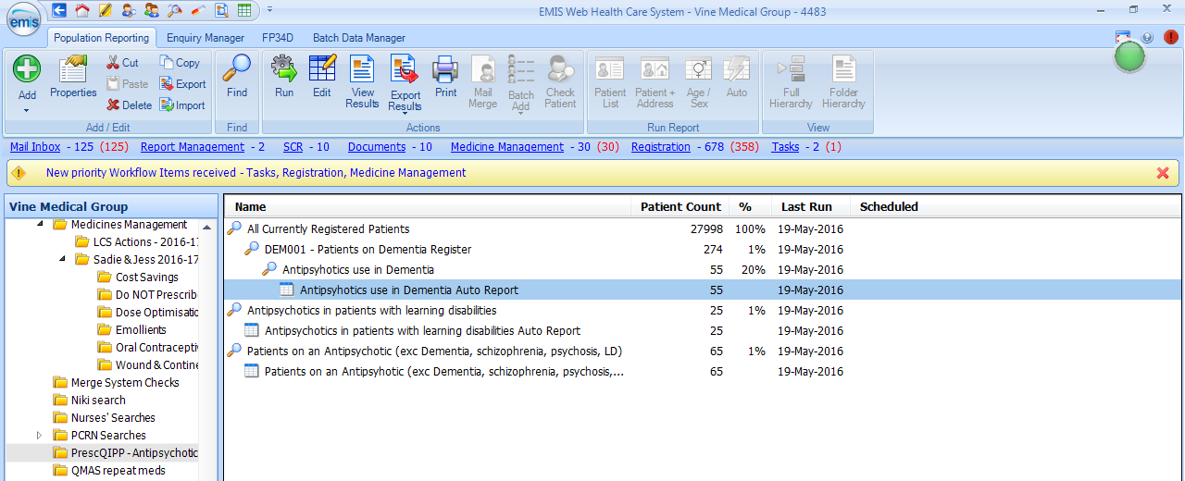

Search 1 - Audit of Anticholinergic Drugs

The search will look for any patients aged 70 or over currently on taking Anticholinergic drugs.
Excluding all palliative care patients.

- When the search and auto report have both run,
- click on the auto report
- click on View results (found on the menu bar)
- Click on “Export”

And check the following boxes;
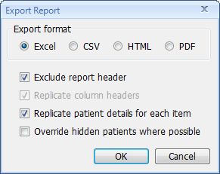

Click on OK to confirm and save file.

Creating a pivot table in excel

Open file and click in cell “A1”
From the menu ribbon select “Insert pivot table”

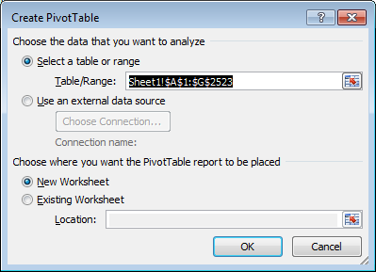

Click on ok to confirm (you don’t need to change anything here)

this will then create a pivot tablet in a separate sheet.

Next, click and hold to drag each field to form the pivot table as shown on the right. When adding the fields under values make sure you do this in the correct order (order as shown here should be replicated under the values)

This will give you a count of how many drugs with an ACB Score of 1, 2 or 3 the patient is currently taking.

Now click on each item under the row labels
Select “field settings” and under subtotals select “None”
This will tidy up the spreadsheet into a single row for each patient.

Now we need to calculate the total ACB score. So we need to add a formula to column H.

You need to rename the columns as below, I have named each column by the ACB value; (this is used in the formula below to calculate the ACB score)
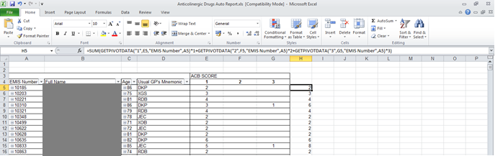

Enter the following formula as shown below, into the cell H5 (you can cut and paste it into the cell)

=SUM(GETPIVOTDATA("1",E5,"EMIS Number",A5)*1+GETPIVOTDATA("2",F5,"EMIS Number",A5)*2+GETPIVOTDATA("3",G5,"EMIS Number",A5)*3)

Press enter.
To complete the rest of the column, just double click when hovering over the bottom right
of the cell to autofill.

That has now calculated your total ACB score for all those patients.

Then from the menu select the “Data” tab and then “filter” you can select which group you want to target.

