Antidepressants – Systm1 Searches

Systm1 Searches
How to import Searches into Systm1

From the reporting toolbar, click IMPORT, and select your rpt file

Select your category and subcategory file
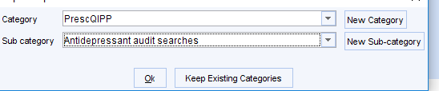

The reports should be displayed in alphabetical order. The numbered reports are the only ones you need to view.

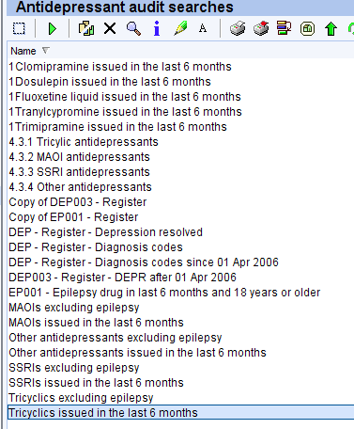
Search 4.3.1 – Tricyclic Antidepressants
Will identify patients prescribed a Tricyclic Antidepressant
Issued within the previous 6 months. Both acute and repeat prescriptions.
Has a read code for depression (same criteria as in the depression register)
Excluding Epilepsy
Excluding Dosulepin, Clomipramine and Trimipramine

Search 4.3.2 – Monoamine-Oxidase Inhibitors
Will identify patients prescribed a Monoamine-Oxidase Inhibitor
Issued within the previous 6 months. Both acute and repeat prescriptions.
Has a read code for depression (same criteria as in the depression register)
Excluding Epilepsy
Excluding Tranylcypromine

Search 4.3.3 – SSRIs
Will identify patients prescribed an SSRI
Issued within the previous 6 months. Both acute and repeat prescriptions.
Has a read code for depression (same criteria as in the depression register)
Excluding Epilepsy
Excluding Fluoxetine Liquid

Search 4.3.4 – Other Antidepressants
Will identify patients prescribed any other Antidepressant
Issued within the previous 6 months. Both acute and repeat prescriptions.
Has a read code for depression (same criteria as in the depression register)
Excluding Epilepsy

Other searches to support Prescqipp materials
Trimipramine
Dosulepin
clomipramine
tranylcypromine
fluoxetine liquid

*Note: with searches there is the possibility that treatment has stopped and been re-started,Dosage changed so the user will have to browse through their drug issue history to check for gaps in treatment.

Searches can be broken down by drug name/presentation, by selecting the symbol in the purple box.

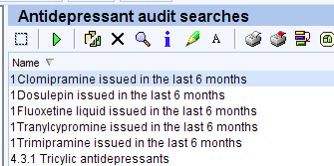

On the left hand side, open up the list to tick the drug box, then click refresh
