PrescQIPP – Gabapentinoid plus an opioid audit
Systm1 search

Import searches:
- Go to reporting.
- Clinical reporting.
- Import (select file).

Run searches:

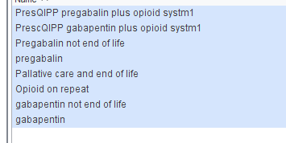

The 2 searches you need to work with are named PrescQIPP.

Build a data output:
Before you view patients you need to build a data output, to show you dose directions.

- Go to Set up.
- Data Output.
- Report Output maintenance.
- New

Add demographics column (Name, NHS number)

Add drug (as action group, name, dose, date, make sure you select the latest 2 or 3 values as this will list each presentation, if a patient is on more than one strength)

You may choose to add opioid action group as above.

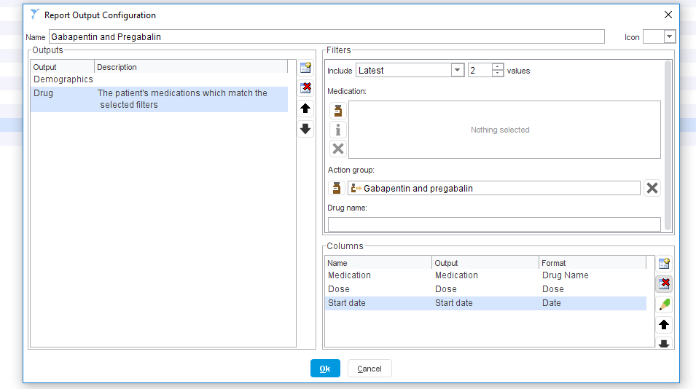

Publish your report output locally:

- Go to your report and show patients
- Click select output, and select the output you have just built.
- Export the data to Excel.

Patients on Gabapentin 1800mg /Pregabalin 300mg per day or more:

You can then sort in excel to highlight patients on Gabapentin 1800mg per day or more and Pregabalin 300mg per day or more.

You need to save the .rpt document on your computer so you know where you are importing the information for the searches / analysis from.

