

Agenda item:

|  |  |
| --- | --- |
| **Subject:** | **Plan to move to greener inhalers** |
| **Presented by:** | **Michael Dennis, Head of Medicines Optimisation** |
| **Prepared by:** | **Michael Dennis, Head of Medicines Optimisation** |
| **Submitted to:** | **Green Group** |
| **Date:** | **January 2020** |

**Purpose of paper:**

|  |
| --- |
| Information |

**Executive Summary:**

|  |
| --- |
| In the 1990’s, metered dose inhalers (MDIs) containing chlorofluorocarbons were replaced with dry-powder inhalers (DPIs) and MDIs containing hydrofluoroalkanes (HFAs). While HFAs are not ozone depleting, they are potent greenhouse gases. The annual carbon footprint (CO2e) of a patients’ inhaler regime can vary from 15kg to 450kg depending on the inhalers used.  In 2017, 70% of inhalers used in England were MDI vs 13% in Sweden.  Changing inhalers would have a considerable impact on the carbon footprint of the NHS especially with promotion of recycling, safer disposal. Reviewing technique and simplifying regimes should also improve the effectiveness of the regimes.  If the changes are planned and phased, then we also have an opportunity to reduce costs. |

1. **Introduction**
   1. The NHS long term plan includes an ambition to reduce the carbon footprint through the shift to using lower carbon inhalers.
   2. Inhalers are estimated to contribute 3.9% of the total carbon footprint of the NHS in the UK.
   3. The draft primary care network (PCN) direct enhanced service also includes an expectation that inhalers will be changed to lower impact products via the structured medication review.
   4. The most commonly used inhaler in the UK is Ventolin and it has a carbon footprint equivalent to 28kg of CO2, that is the same as a standard car journey from London to Sheffield (175 miles).
   5. It will not be possible to switch all patients to greener inhalers however as some will still need MDI’s in emergency or won’t be able to manage the technique of an alternative. This is entirely acceptable as we are aiming to significantly reduce our use of less green inhalers and not to completely eradicate their use.
2. **Current position**
   1. Openprescribing.net has an indicator that shows percentage of MDI vs all other inhaler types. This doesn’t take account of the fact that some MDI’s have a significantly lower carbon footprint than others. The differing global warming potential of the inhalers is, in some cases impossible to calculate as some manufacturers do not list the type and amount of propellant on their patents.
   2. The STP position in October 2019 is below, when excluding salbutamol inhalers, the percentage is above average at 56.84% and is at the 71st percentile nationally

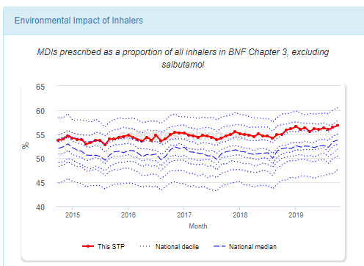

1. **Proposed work**
   1. It would be sensible to make this very much a public facing campaign with local practice performance visible on the CCG website. In making this change it is very important that the more cost-effective inhalers are switched to. The programme could otherwise increase our costs.
   2. We should also promote patients returning used inhalers to pharmacies for recycling. Currently, not all pharmacies are taking part in the scheme. I have contacted the LPC to let them know of our plans to publicise the service.Where used, the aluminium, plastic and propellants can be reused.
   3. If a pharmacy isn’t taking part in the recycling then taking inhalers for safe disposal is still greener than binning them. The high temperature incineration means that the gas is denatured and no longer a hazard to the environment.
   4. I would propose that this is tackled in a phased manner working on the highest GWP products first. This will allow us to have the biggest impact first and to make the inhaler switch message simpler. The two products with the highest environmental impact are Flutiform and Symbicort MDI as they use HFA227, the next highest impact is from Ventolin, this uses HFA134a but it is a high volume inhaler. Changing to Salamol MDI or salbutamol Easyhaler will reduce the carbon footprint.

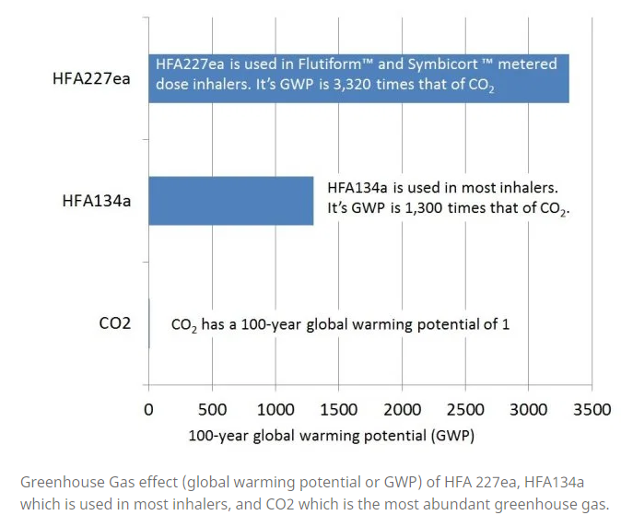

* 1. Useage data and patient numbers for October 2019 is below

|  |  |  |
| --- | --- | --- |
| Year Month | 201910 |  |
| Commissioner / Provider | (All) |  |
|  |  |  |
| **Row Labels** | **Sum of Items** | **Sum of Identified Patient Count [1 of 2]** |
| Ventolin_Evohaler 100mcg (200 D) | 12024 | 10676 |
| Flutiform_Inha 125/5mcg (120 D) | 1447 | 1288 |
| Flutiform_Inha 250/10mcg (120 D) | 1086 | 939 |
| Flutiform_Inha 50/5mcg (120 D) | 362 | 331 |
| Symbicort_Inh Pressurised 200/6mcg(120D) | 181 | 161 |
| Flutiform_K-haler 125/5mcg (120 D) | 13 | 11 |
| Flutiform_K-haler 50/5mcg (120 D) | 6 | 3 |
| **Grand Total** | **15119** | **13409** |

* 1. Patients can be informed by letter of the imminent change and advised that their pharmacy will show them, train and assess compliance with the new device/s as part of the funded ‘New Medicines Service’. This has follow up built into it.
  2. It has to be accepted that patients will still need salbutamol MDI and spacer in most urgent situations. Environmental impact can be reduce by the use of the lower volume Salamol MDI.
  3. We will continue our work of previous years to use pharmacies to demonstrate and train patients on inhaler changes. The LPC are supportive of this.

1. **Recommendations/next steps**
   1. The committee is asked to note this report.
2. **Further Reading**
3. <https://greeninhaler.org/>
4. [Wilkinson AJK, Braggins R, Steinbach I, et al. Costs of switching to low global warming potential inhalers. An economic and carbon footprint analysis of NHS prescription data in England. BMJ Open 2019;9:e028763. doi: 10.1136/bmjopen-2018-028763](https://bmjopen.bmj.com/content/bmjopen/9/10/e028763.full.pdf)
5. [Janson C, Henderson R, Löfdahl M, et alCarbon footprint impact of the choice of inhalers for asthma and COPDThorax 2020;75:82-84](https://thorax.bmj.com/content/thoraxjnl/75/1/82.full.pdf)

**Recommendation to Governing Body/ Committee:**

|  |
| --- |
| Members are invited to note this update on current practice performance and on the work being done by the medicines team to help practices prescribe more cost-effectively. |

|  |  |
| --- | --- |
| **Key Risks** | |
| **Clinical and Quality:** | Unwarranted clinical variation may have an impact on quality of care |
| **Finance and Performance:** | Significant overspend due to clinical variation |
| **Impact Assessment (environmental and equalities):** | N/A |
| **Reputation:** | N/A |
| **Legal:** | N/A |
| **Information Governance:** | N/A |
| **Resource Required:** | N/A |
| **Reference document(s):** | N/A |
| **NHS Constitution:** | N/A |
| **Conflicts of Interest:** | GP members may be conflicted |
| **Reference to relevant risk on the Governing Body Assurance Framework** | N/A |

**GOVERNANCE**

|  |  |
| --- | --- |
| **Process/Committee approval with date(s)** *(as appropriate)* |  |