Your salbutamol inhaler is changing to a more environmentally friendly version - Salamol®
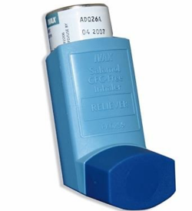
Use your new Salamol® inhaler in the same way as your current salbutamol (reliever) inhaler. It may look a little bit different, but you shouldn’t notice any difference in the way that it works. You can ask your doctor, nurse or pharmacist if you are concerned about this change.
Salamol® is the same type of inhaler and contains the same medicine, (salbutamol) as your current inhaler. It might taste a bit different to your current inhaler. It has the same type of side effects as your current inhaler.
Salamol® has less greenhouse gas than your current inhaler and so is more environmentally friendly.

Why use a more environmentally friendly inhaler?
The NHS supports the change to more environmentally friendly inhalers if this is the right choice for you.
The gas in your current inhaler is a powerful greenhouse gas. This means that when the gas is released, it stays in the air and traps the sun’s heat, like glass in a greenhouse. This warms the planet which is a problem for the climate. Climate change increases air pollution which can worsen lung conditions.
So, by changing to Salamol® you can help reduce climate change and reduce your lung risk caused by increased air pollution.
We don’t think you will have any problems changing to Salamol®.
You can contact your doctor, nurse or pharmacist if you have any concerns.

